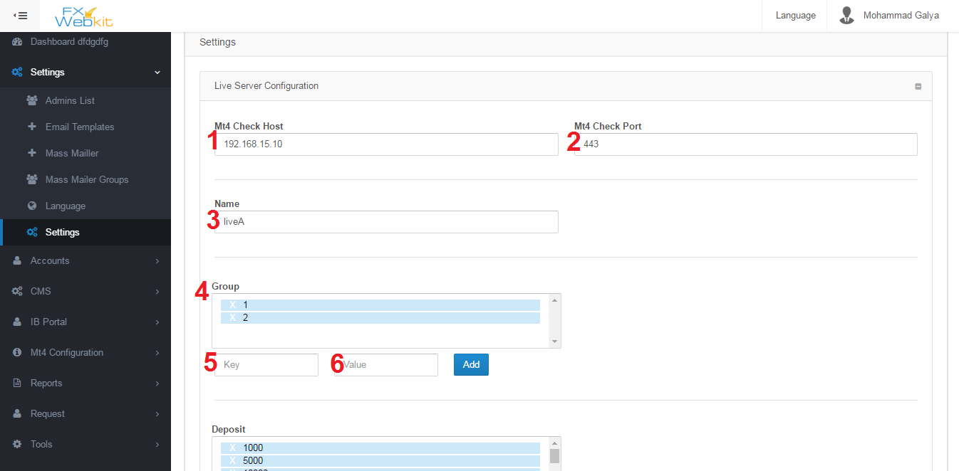

Public settings for the software and server settings you can edit them here :

1. MT Check Host : meta trader server IP .
2. MT4 Check Port : meta trader server port to connect with server throw it.
3. Name: Name of server where every Mt4 users will be distinct according to the server if it's Live server ,demo or you can name the server.
4. Group: Mt4 Users in the server belong to groups so if admin or client wants to add new Mt4 user he has select the group.
5. Key : when software display the list of groups it will display the value and the key for the server so you are free to change value but the key should be come from the server and you cannot change it.
6. Value : descript the group or alias for the group and you can change it as you want.

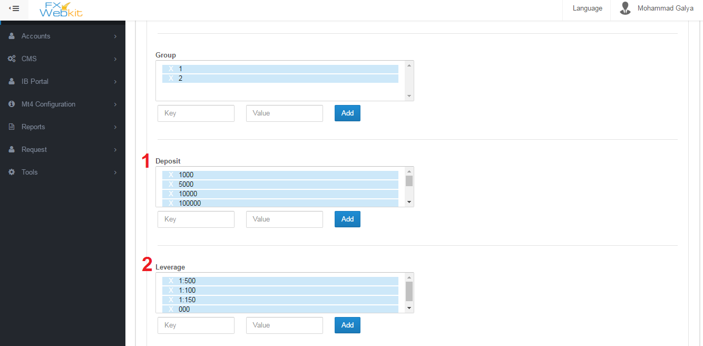

1. Deposit : List the deposit numbers which available on the server and you can delete any one and add also but be careful with key you have to ask server software developer to know what keys available and you are free with value.
2. Leverage : lest of leverage on the live server .

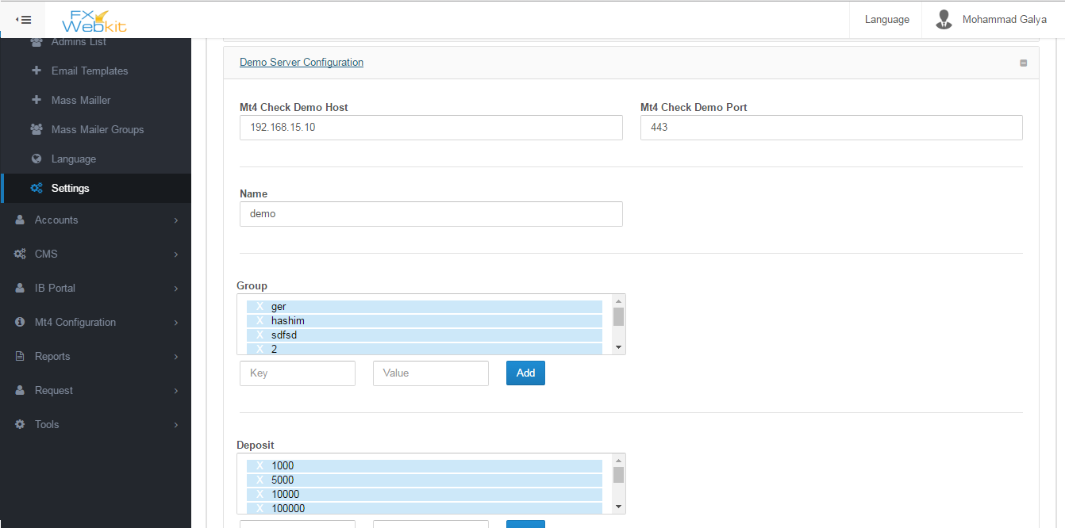

As we see in live server here we have the same settings for demo server and you can set different settings.

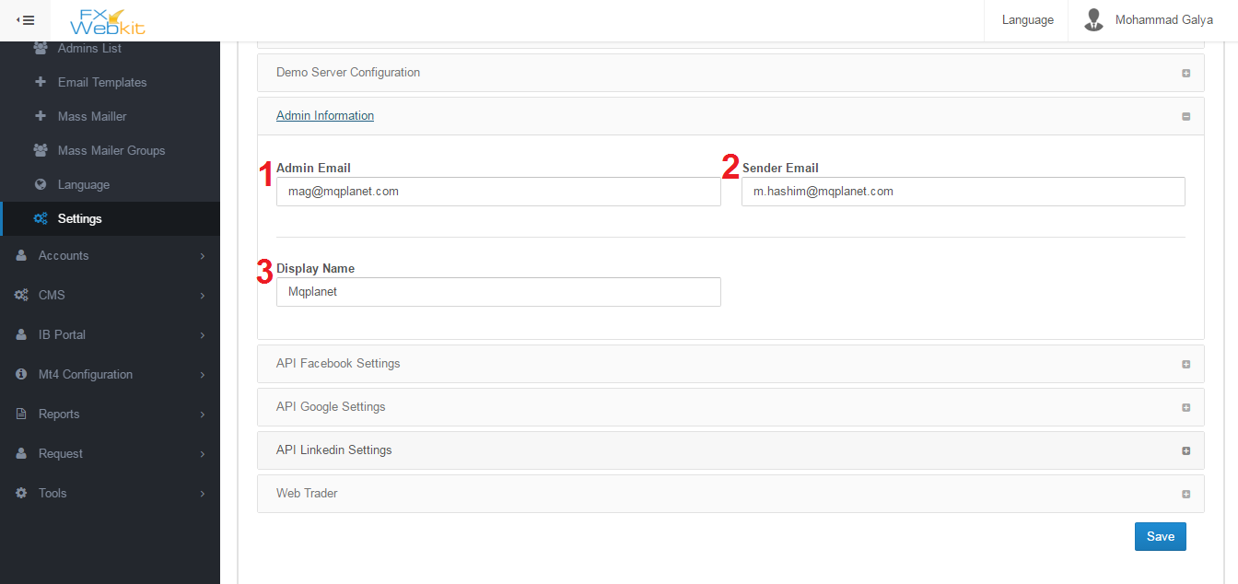

Each Admin has his own info you can see it from users list (admins list ) but this info will be the same for all admins in general you can descript them as email sender settings.

1. Admin Email : for each notification from the software it will sent to this email and all mass mails will be sent to this email.
2. Sender Email : this the email which will all emails out from .
3. Display Name : name of the sender in emails.

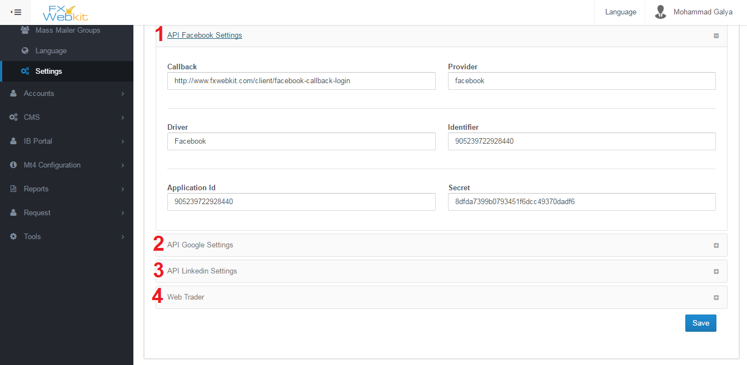

Fxwebkit client area can be entered by registration or login throw social media and to do this operation you have to make applications on the social networks like facebook , google+ and linkedin:

1. API Facebook : you can create your own API . please see <https://developers.facebook.com/> to more information about facebook login API.
2. API Google : you can create your own API . please see https://developers.google.com/ to more information about Google login API.
3. API Linkedin : you can create your own API . please see https://developer.linkedin.com/to more information about Linkedin login API.
4. Web trade : the link for online web trade can be inserted here this link can be display or hidden from client. when you make it available to client by check the check box in this tab there will be new window in client area to trade online.

**Accounts**

Accounts List:

The accounts list is the list for clients who can enter client area of this software . we have seen Accounts list of admins the same thing for clients' accounts but with more actions on them:

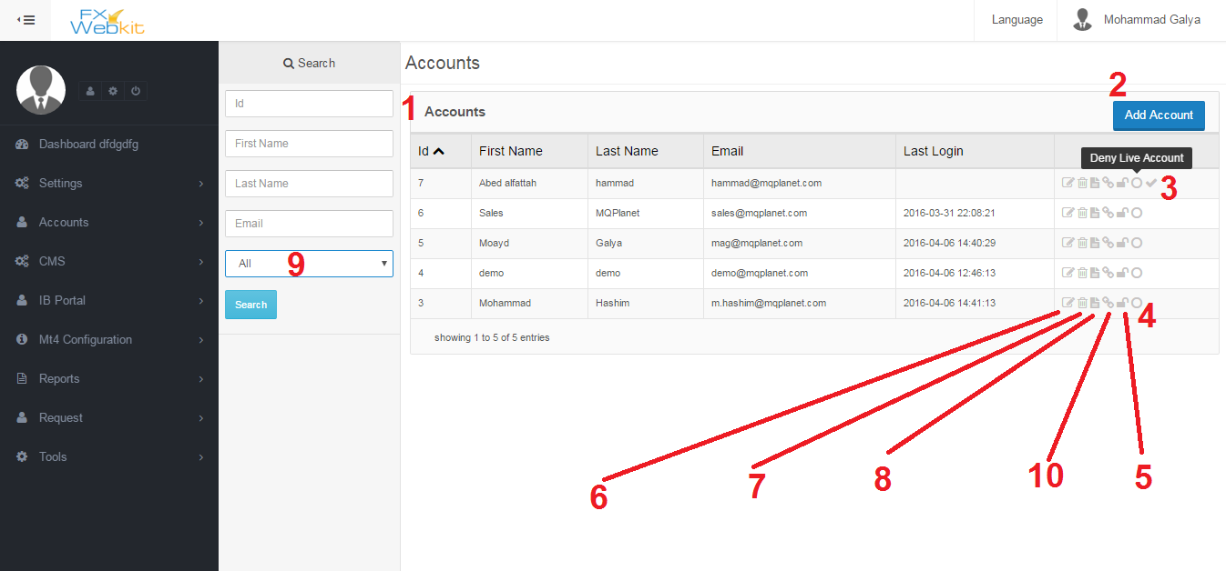

At the first time you enter this window you have to click search button to see the list i.e. the list will be empty until you click search button and the window contain:

1. Clients accounts list : all users who can enter clients area will be listed here .
2. Add Account : this button to add new client press the button fill the details and click save and the new user will be listed here.
3. Active account : when new client register in the client area for the first time his account will be not active until (according to software configurations) he go to his email and click activations button (note :you can edit sent email template using settings ->email templates) ,but when you click this activations icon the client account will be active without go to his email ,then he can enter his account.
4. Deny Create live account: the clients can add Mt4 Users to Live server as we'll see this button can deny some client from create live MT accounts on Live server or allow him.
5. Block Client : toggle this button to block or unblock client when client is blocked he will not be able to log in client area.
6. Edit Client information: like admins list this icon to edit client info email, password …etc.
7. Delete Client: when click this icon the client will not be longer exist .
8. Client Details: client info and personal details .
9. Filter users: If you want filter users and see the active accounts and non-active accounts .
10. Assign MT users to client : every client have number of MT users on live server and demo server , to determine each client MT users use this button to get into assign MT users to client window .see below window:

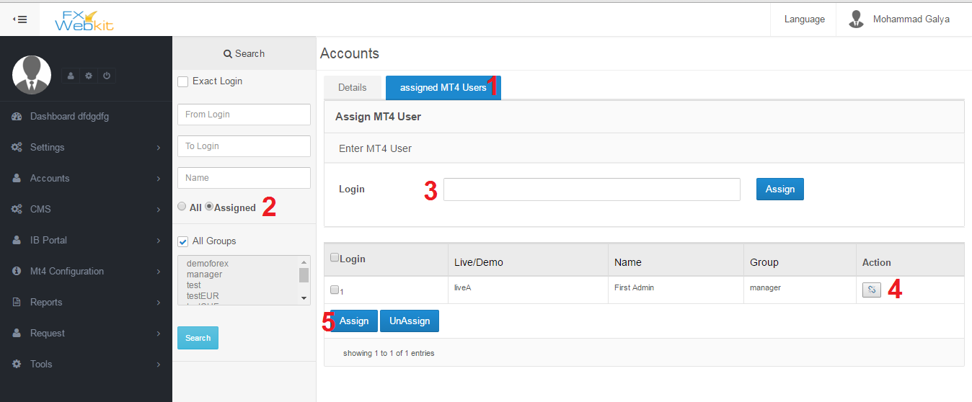

To specific each client MT users so when the client enter clients area he can manage his own MT users and see their details:

1. MT Users list : if you click this tab you see MT users to the client which we click on in users list to see this user details use Details tab .
2. Display All MT users or just this user MT users : filtration the listed users if you want to see all MT users check All and click search then assign new MT users to this user . Check assigned then search to list this user (client ) MT users.
3. Fast assign Login(MT user) : just type MT users login and click assign to add this MT user to this client.

Note : the login will be assigned as alive MT user, to assign demo MT user check All in filter panel and search find your login and click assign button at the end of the row.

1. Toggle Assign & unAssign button: click this button to assign MT user to this user and click it again to un assign the MT user.
2. Multi assign and un assign button: display all MT users using filtration then check the MT users after that you can assign them or un assign them once.

MT Accounts:

In the system we have two server live and demo with MT users on them this window to manage those MT accounts :

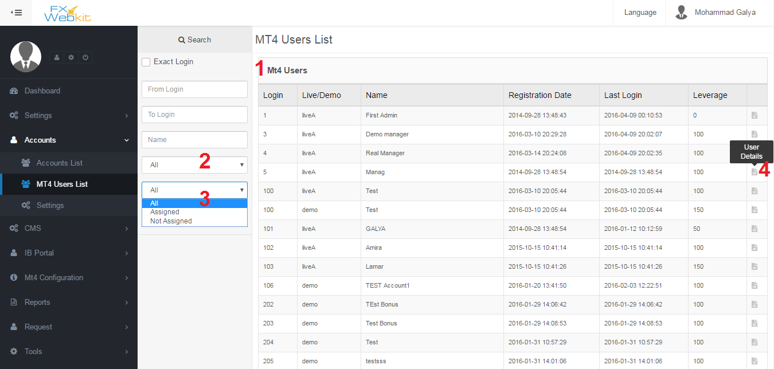

All MT users live and demo are listed here :

1. MT users list: list of users in live and demo servers.
2. Filter users live or demo : you can filter users and distinct the live or demo users just select which users you want listed and click search button.
3. Filter Users (assigned and Not assigned): as we see for each system client in past Accounts list has MT users assigned to him this filter will display list of assigned MT users which assigned to one of fxwebkit clients or unassigned MT users.
4. MT user details: To manage this MT user click on user details icon to see this user summary change leverage, password, internal transfer and withdrawal ,also you can see for any Client( Fxwebkit user) this MT user assign to. See:

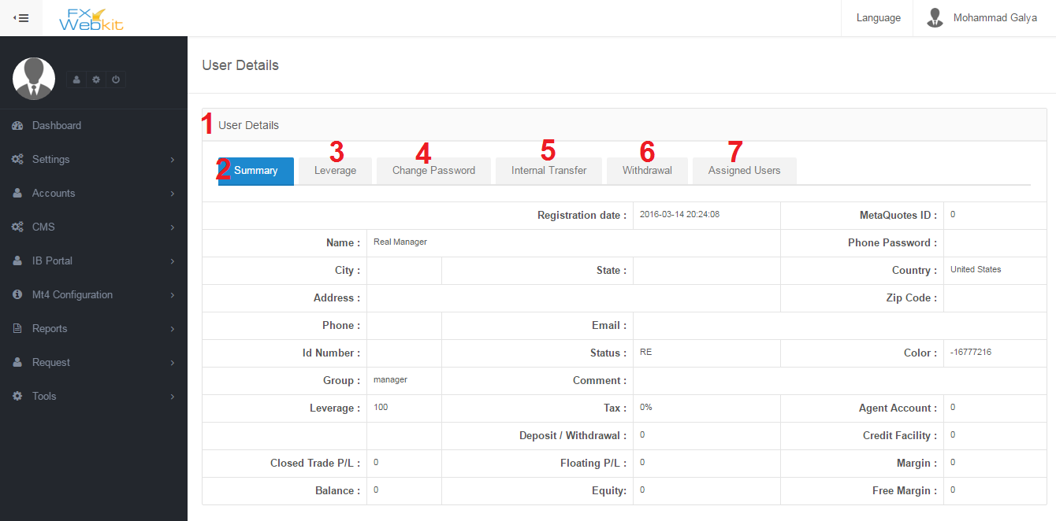

MT user details for live or demo users and change this details :

1. MT users details : all MT user details with tabs to change some sittings of this MT user throw sending request to the server to change those settings.
2. Summary : display info of MT user.
3. Leverage : this tab to change MT users leverage you will find list of available leverages on server which we talk about early in the public settings tab .
4. Change password: MT user password change which he use to login to the trading platforms .
5. Internal transfer : transfer money from this MT user to another user ,just insert MT login and amount and send button .

Note : the admin can control the send to accounts so he can allow if this user can send to any MT user or just to his MT users , we will see this option in the next settings window.

1. Withdrawal: just type the amount and click send .
2. Assigned Users: Client users(Fxwebkit users) has their MT users so to see which user this MT user belong to click this tab to list users that this MT user belong to and remove this relation(un assign ) any one of them.

**Settings :**

This setting just for accounts module to configuration Accounts module and MT users operations :

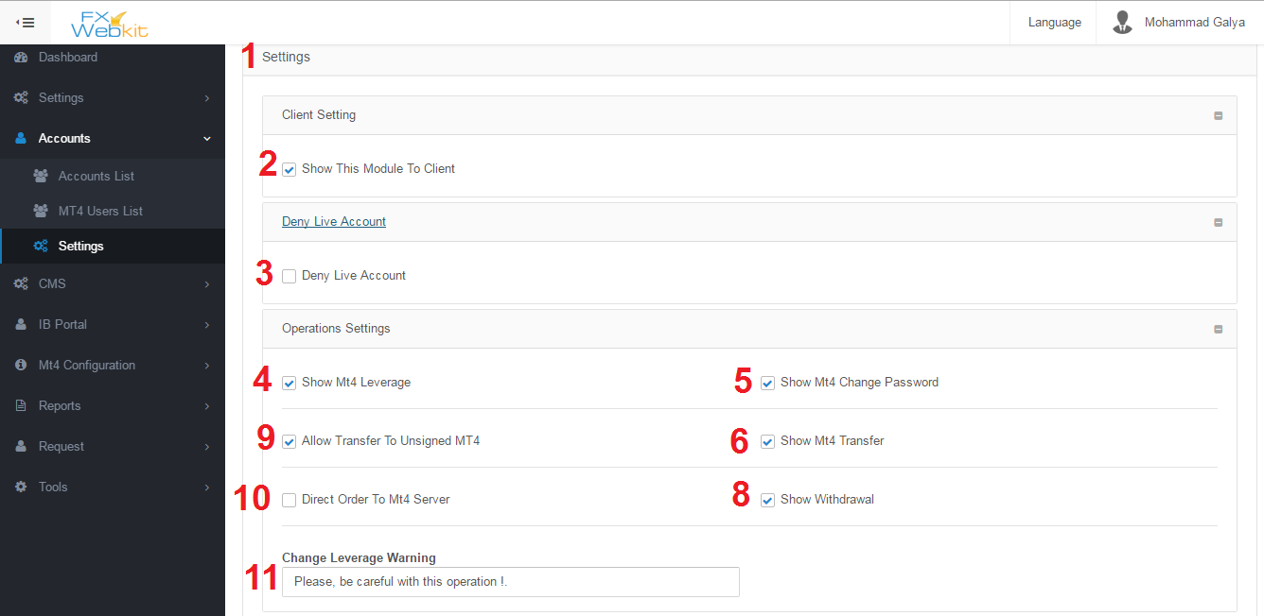

Settings to control accounts and Mt4 operations:

1. Settings Tab: contain multi tabs to categorize setting according to their uses.
2. Show this module to client: in the client area there is accounts menu and to hide it from client area just remove check from this checkbox.
3. Deny Live Account : when new client register in the Fxwebkit software if this option checked the client cannot create live MT user until the admin allow him by check the icon on accounts list on users list(see number 5 in accounts list ).

But if this option not checked and new user(client) register in Fxwebkit then the admin checked this option the user can create live MT account until admin deny him from creating MT live account.

1. Show Mt4 Leverage: in MT user details window there is Change leverage tab this tab can be hidden to client if this option not checked.
2. Show Mt4 Change Password: in MT user details window there is Change Password tab this tab can be hidden to client if this option not checked.
3. Show Mt4 Internal Transfer: in MT user details window there is Internal Transfer tab this tab can be hidden to client if this option not checked.
4. Show Mt4 Withdrawal: in MT user details window there is Withdrawal tab this tab can be hidden to client if this option not checked.
5. Allow Transfer To unassigned MT users : The client (Fxwebkit user) has his own MT users if he want to transfer money between them he can use internal transfer in MT users details. But if he want to transfer money to other MT users(who are not assigned to him ) he cannot if this option not checked.
6. Direct Order To MT server : we have some orders like change password, change leverage , add new MT user , withdrawal and internal transfer those order sent to MT server and apply them there if you want filter these orders and send them first to admin (requests Module) then the admin choose to forward order to the MT server or control them before send them to the server just remove checkbox check to filter orders and deny direct order to MT server.
7. Change leverage warning: this message will be display to client in change leverage tabe.

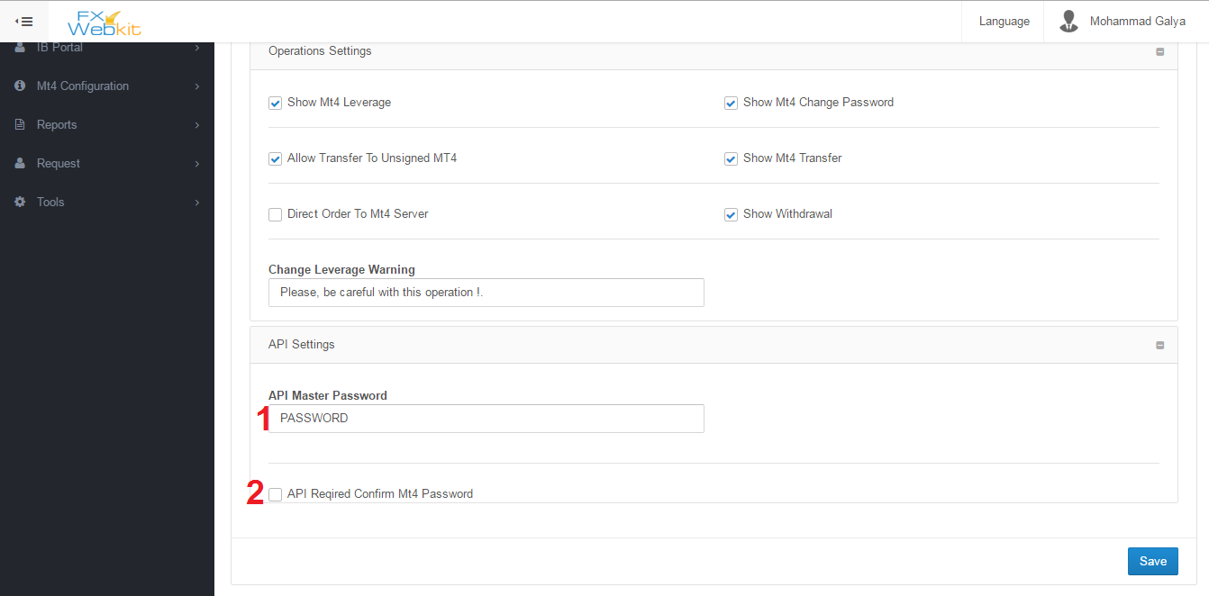

This settings for API developer :

1. API Master Password : this password will be sent with request for MT server.
2. API Required Confirm MT password: If the API developer need MT user password to confirm order ,the client need to insert the MT password with each order like change leverage.

CMS (Content Management System):

Fxwebkit software comes with a very awesome features which is built in CMS to manage website public area content, add articles, reorder website, add pages, translate even custom code like HTML and Javascript and change the whole theme .

Features:

1. User interface to edit public website without need for developer.
2. Easy to use and fast adding new content.
3. New page by clicking few buttons.
4. Translate and add new language.

Content:

1. Pages:

To add new page to the public website

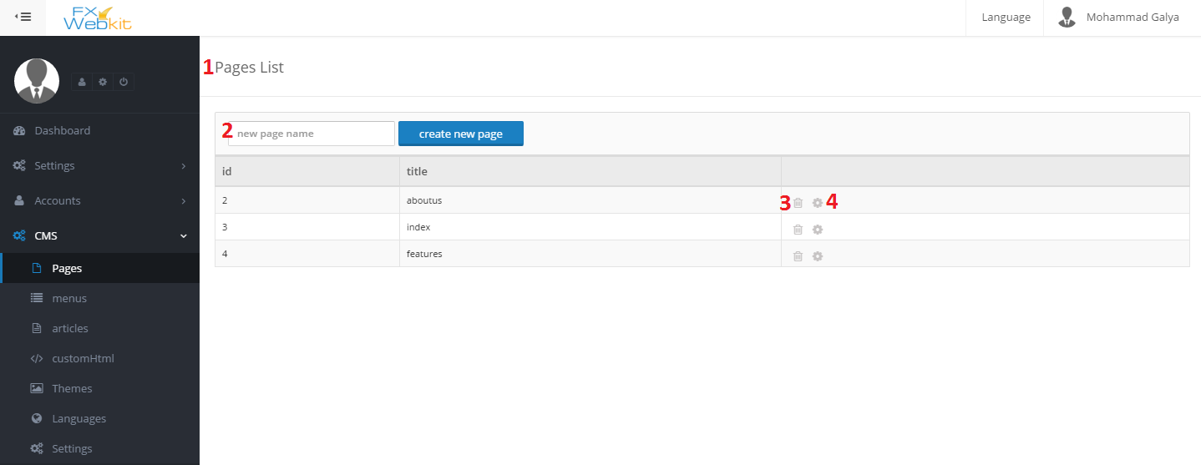

1. Pages List : each page in the public web site will be listed here .
2. New Page Name: to create new page in the public website type the name of the page and click create new page button to edit content of the new page , we will use page name to create menu link (menu item) for this page.
3. Delete Page : to remove the page from the public web site, the contents of the page are independent from the page because the page tell the content how to look or its positions in the page so the content will be not deleted .
4. Edit page icon: to add content for page , reorder content .when you click this icon the following window will be displayed :

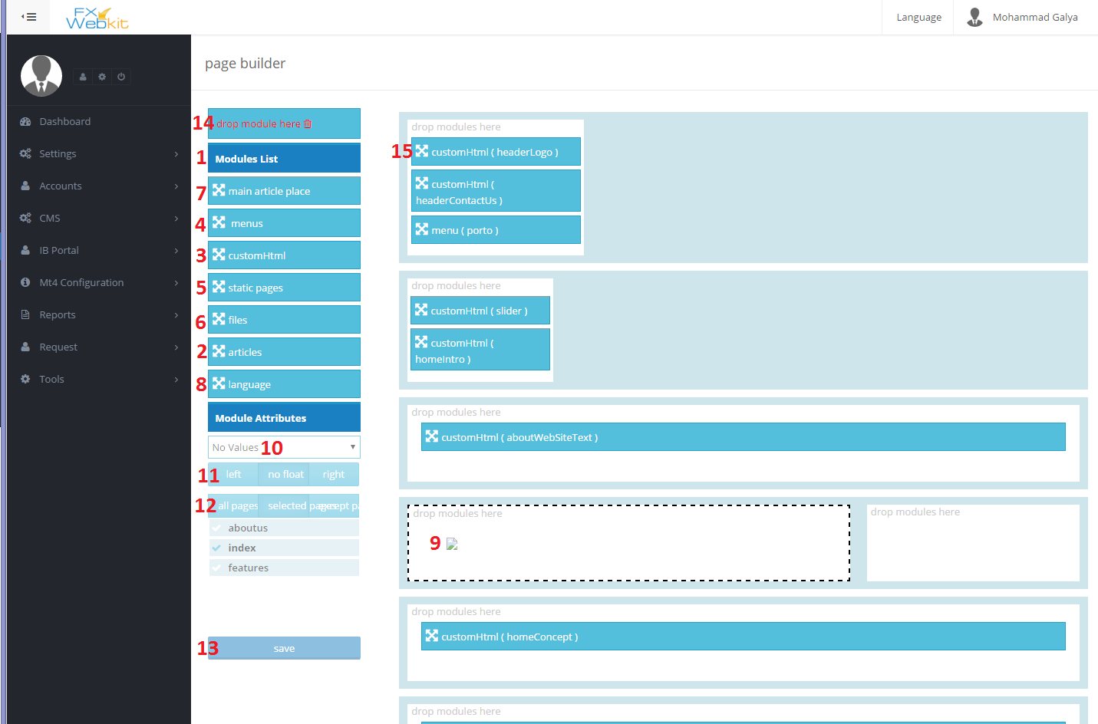

This page to reorder content and insert new content :

1. Modules List : all what you can add to public website pages will be listed here . you can add different types of content like articles , html file, custom HTML , menus and languages dropdown.
2. Articles : in the CMS we have tab for write articles and save them(we will see it). To add these articles to website drag this article button and drop it in white place at the right (number 9) after drop it select article name from dropdown (number 10) and configure the article align (number 11) , select the pages that you want to display this article on or all pages(number 12) then click save button (number 13).
3. Custom HTML : to add new custom HTML create custom HTML from custom HTML menu then do the same scenario (drag drop in the right place configuration finally click save )
4. Menus : see menus in CMS module to create menu with its menu items then come here drag and drop it in the right place of page configure it and save.
5. Static pages : the CMS module allow you to create your own modules different from built-in modules just do the same for add article.
6. Files : if you have HTML files and to group them in on module to insert them in the website just create module to them and drag drop the module in the right place select the wanted file then configure it to insert content of the file in this place.
7. Main article Place: we see articles module this module little bit different drag drop this module in the right place this module has no dropdown content(number 10) but when you create new article in article menu you can select the page that you want to display on without go to the page and insert the article in after choosing the page to display the article all what you have to do is create menu item for the article not for the page then when you call this article (click on menu item ) the page will get article and insert it in Main Article Place and display the page.
8. Language : this module insert dropdown select with all languages in cms menu languages, when the users change the language all articles and other modules will be inserted according to the selected language.
9. Place to insert modules in : this place present a position in the public website theme when you drag and drop module in this place it will be inserted in the theme so when users visit public website , you can also reorder modules with drag and drop and change position of module according to the theme section .
10. Module Content: some modules require to select type or value of the inserted module like articles when you want to add article on the page we drag drop the article button then we select the article that we want insert.
11. Align module in the position: this option to align the module to the right or lift in the theme position.
12. Module pages: select the pages that you want to display the module on you can select all to display it in all pages.
13. Save button : to save the module place with its configuration.
14. Delete module : drag the module from its position and drop it on the delete icon to remove this module from this page (it’s will not delete the module like the article itself just remove it from the page).
15. Module Button: this button represent the module that you added to the page, you can reorder modules and change its position by drag drop it.

Menu:

To navigate the public website you need links to connect pages together , we need to know that the website may have more than on menu navigator like footer menu , header menu and aside menu so we have menus list and for each menu we have menu items :

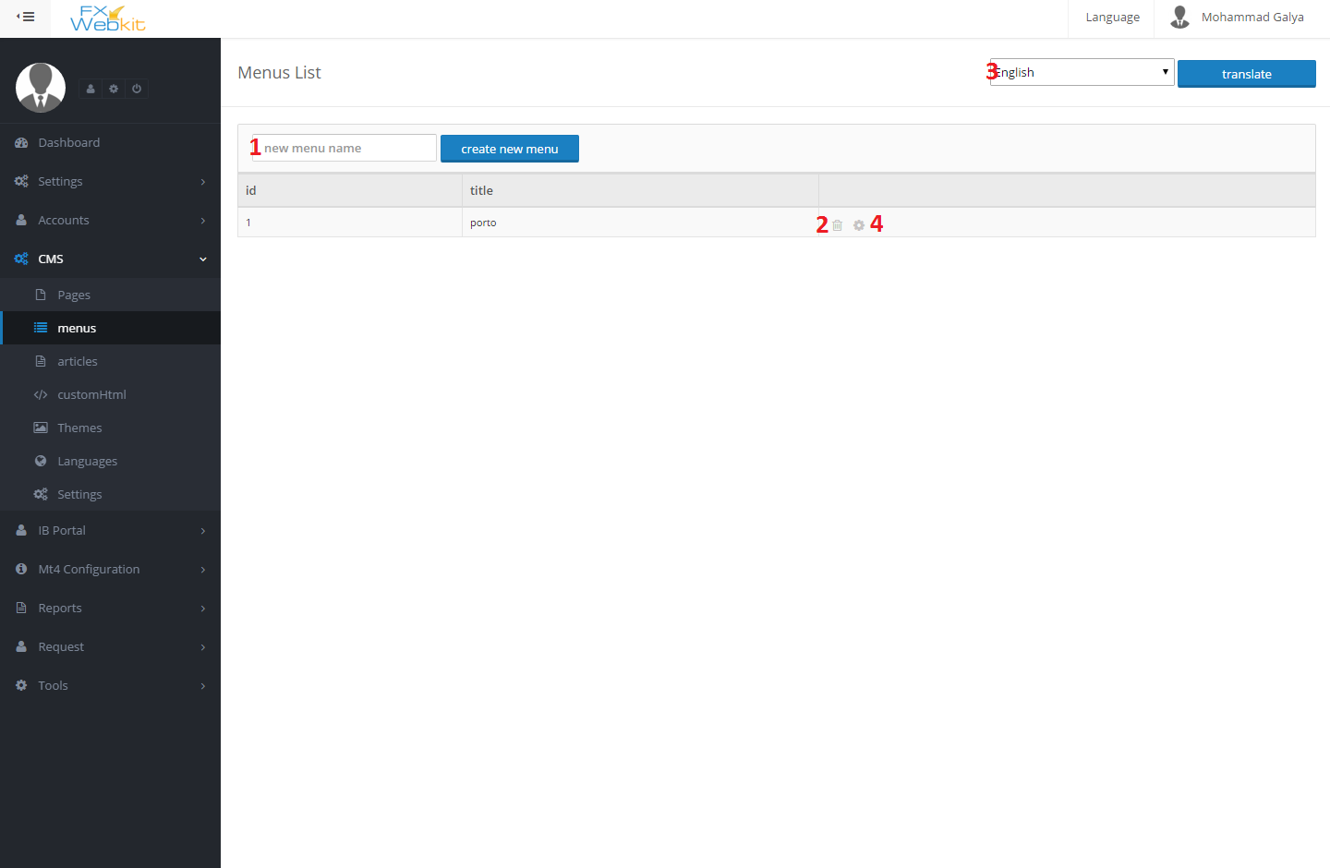

1. New menu name : this name just to group menu items under one menu .
2. Delete the menu: delete the menu with all its menu items.
3. Translate menu: change language to translate the menu to another language.
4. Add Menu items: to add ,remove menu item click this icon to get into the next window:

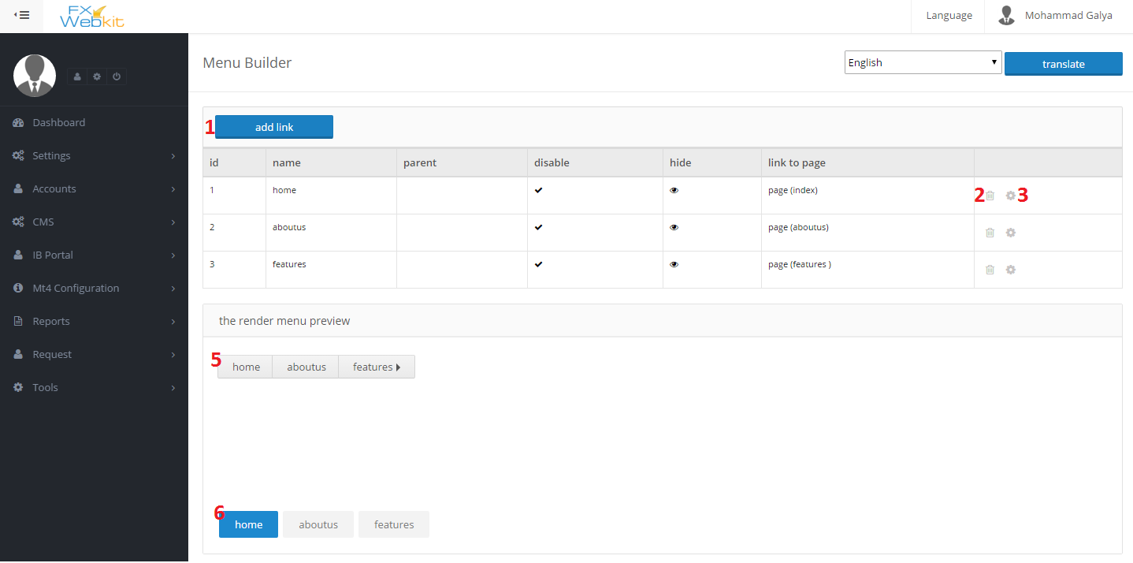

1. Add new link button: click this button insert link info (the next window describe add menu item menu).
2. Delete menu item : remove the link from the menu and database.
3. Edit menu item : to change link refers to or configurations .
4. Preview the menu : this preview to show the standard rendering for this menu.
5. Preview the menu with the current CMS theme: how the menu will be look like in the public website.

Add Menu Item window:

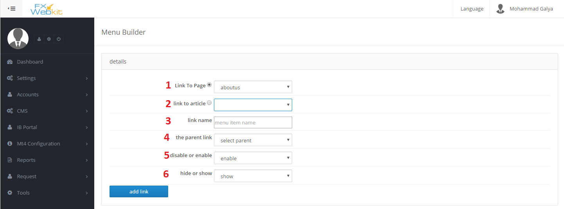

1. Link To Page: menu item(the link) can go to the page or to article just check radio button to the page and select the page name from dropdown menu.
2. Link To Article : If you select to make this link refers to article check the radio button select the article from the drop down menu then if the user in the public website he will go to the page which we select when we add new article in the CMS and the place(position) of the article in the page will be in the MAIN ARTICLE PLACE module which we drag and drop when we create the page.
3. Link Name: link name is the word which will displayed in the public website.
4. The Parent Link: to display this link under another link or sub of another link choose the parent link.
5. Disable or Enable: choose disable it will display but it will not be active on click on it
6. Hide or show: hide the link from public website.

CMS Articles:

You can write any article and determine the page that this article display in so when you add new link to this article it will auto displayed in the selected page in the MAIN ARTICLE PLACE.

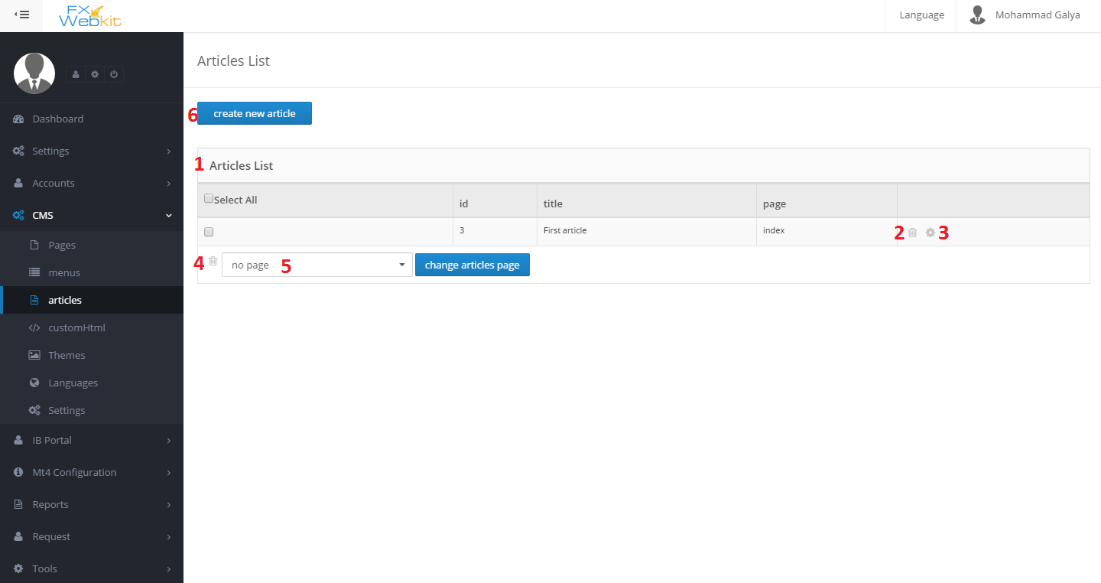

1. Article List: all articles will be listed here.
2. Remove the article : remove the article with its translates.
3. Edit the article : to edit the article title and body also you can insert new article using this article i.e. change this article and click insert new article in the edit article page so the original article will not be changed and new article with new edits will be create.
4. Delete group of articles: check the articles that you want to delete and click delete icon.
5. Change article page: as we see each article has page that page will be displayed when click on article link in the public website link and the place of article will be MAIN ARTICLE PLACE, check the articles that you want to change its page (the display page) and choose the page click change articles page.
6. Create New article: to create new article see below :

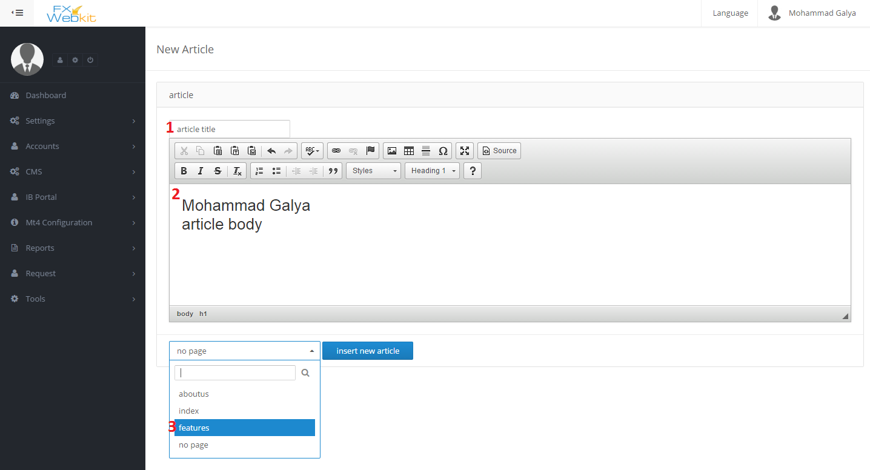

1. Article title: this name will used for each use for this article and will not be display in the website.
2. Article body: the body of the article you can insert html and css.
3. Article page : the page which will display the article in its(page) MAIN ARTICLE PLACE position.

Custom HTMl:  
same as article but no need to determine the page but you can insert it where ever you want in the page positions.

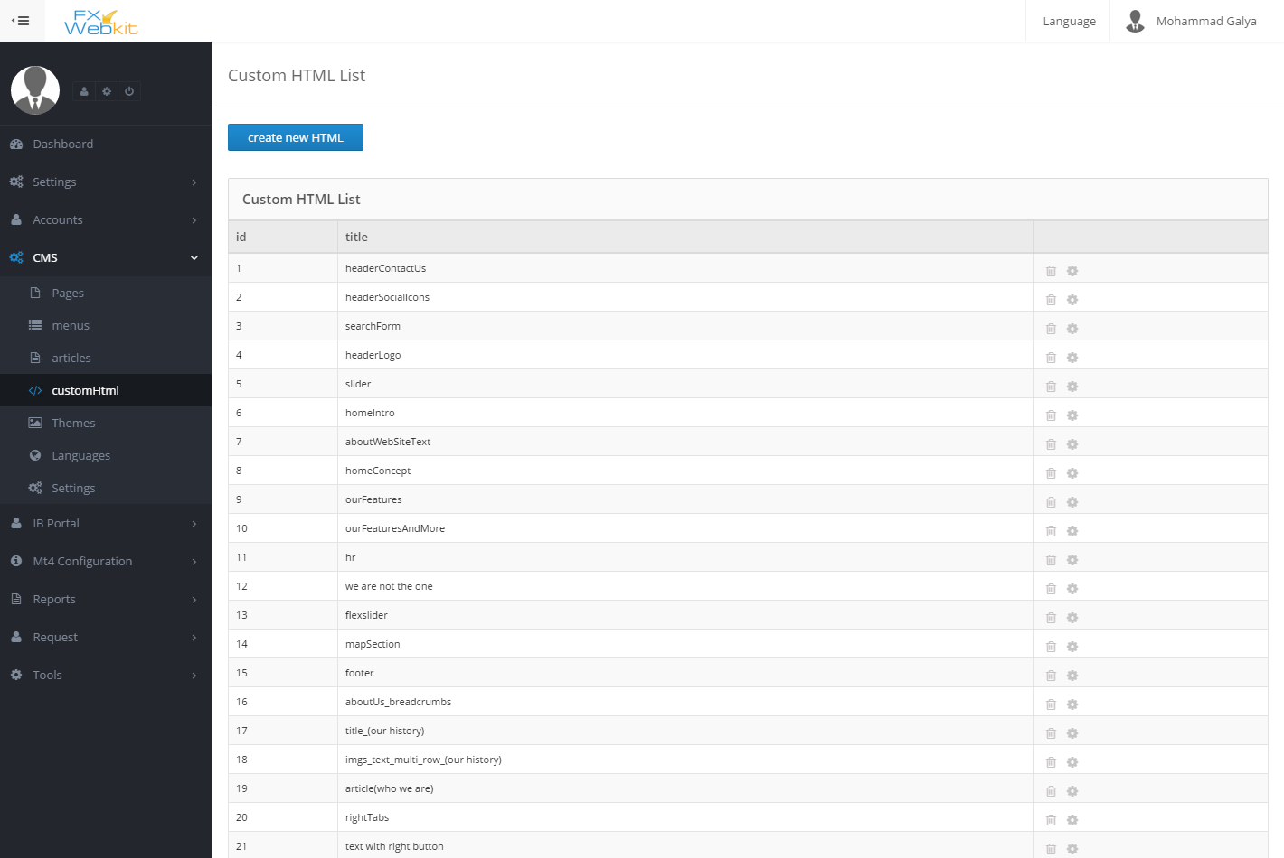  
as same as articles without selection for page.

Languages:

To translate everything in CMS you need to insert the languages first then go to the wanted thing that you want translate ,select the language and translate.

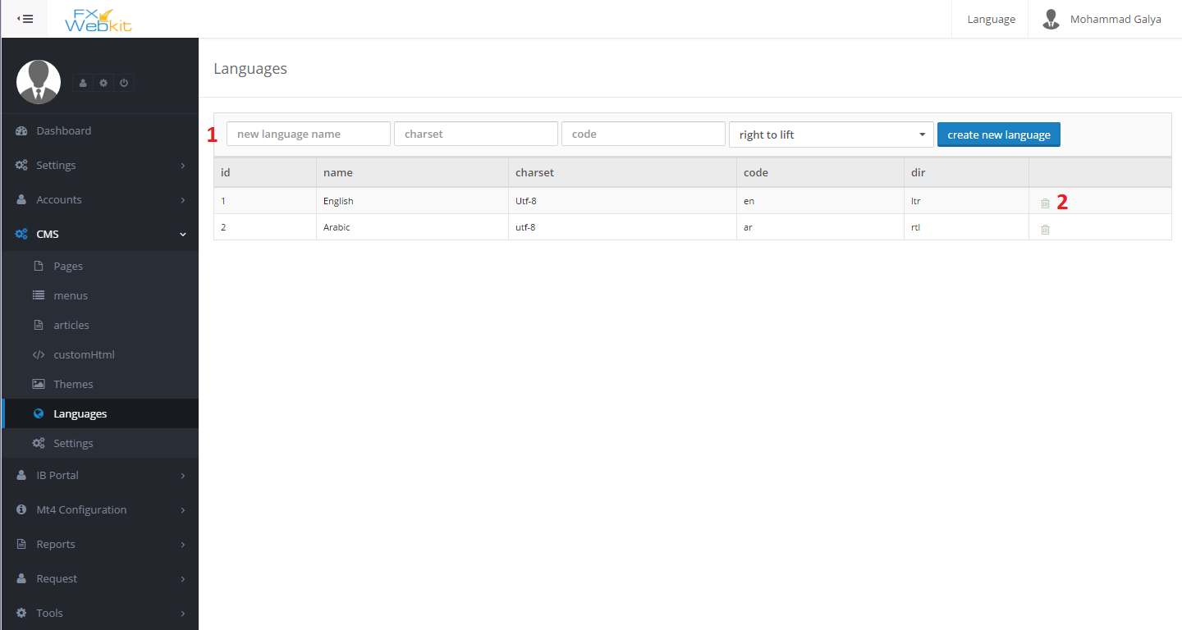

1. Language info: insert language info name , charset, code and direction then create new language button.
2. Delete language: remove language and all translation for this language.

CMS Settings:

These settings to configuration the CMS and theme developer settings :

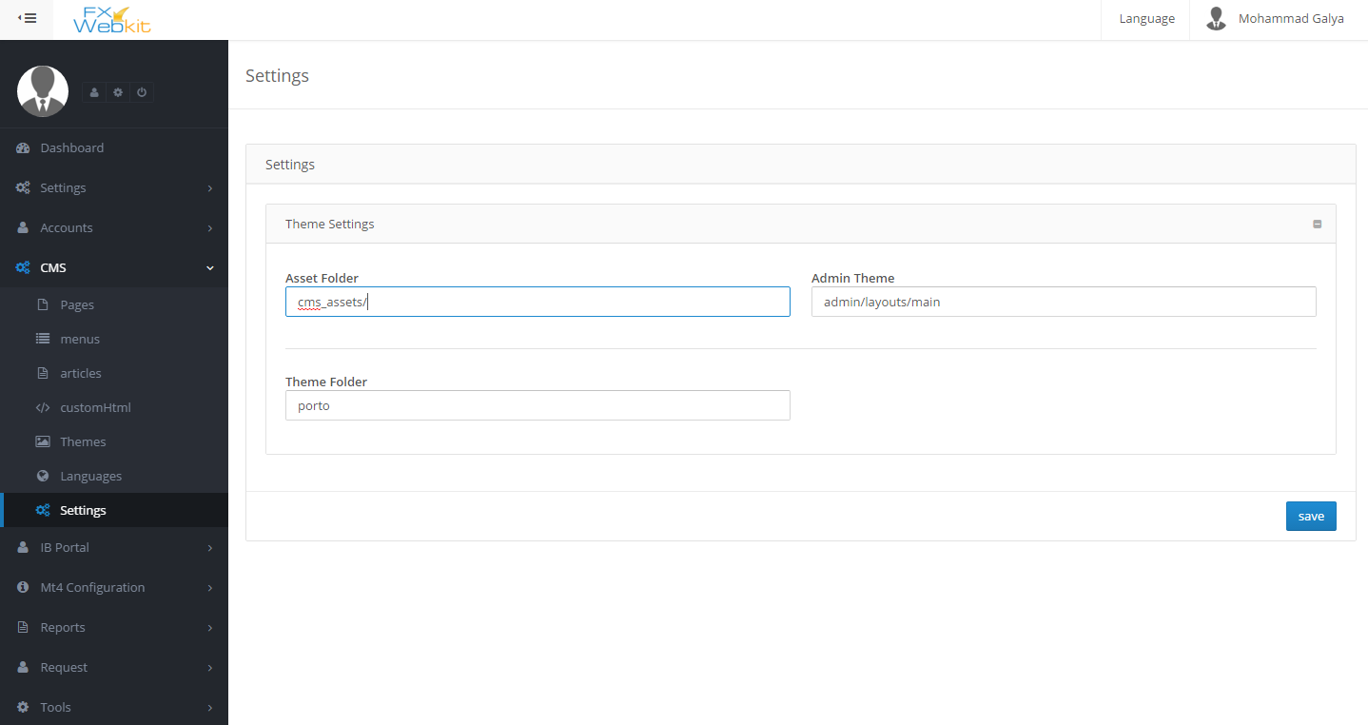

IP BORTAL:

To manage the agents and their configuration with plans for each agent.

Feature:

1. Easy to manage agents accounts.
2. Calculate agents commission and their users.

IP BORTAL content:

Plans:

The way of dealing with agent and how the commission will be calculate for each symbol:

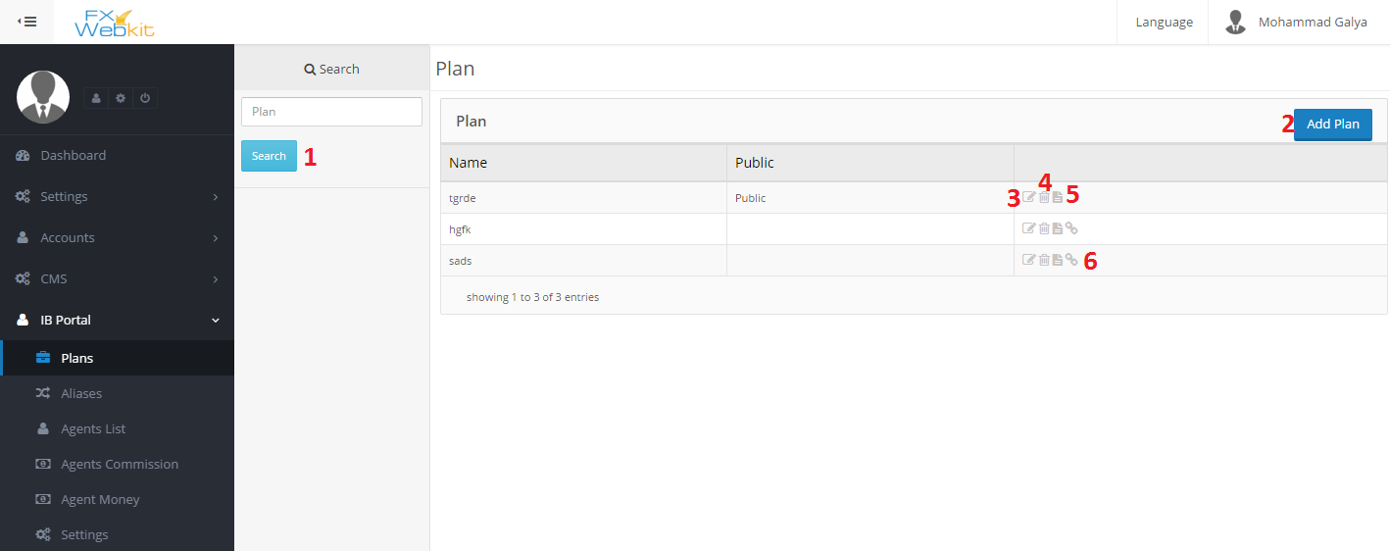

1. Search button: To list plans click search button even if you do not search. The list will be empty until click search.
2. Add New Plan: click add plan and insert plan name and type of the plan if its public it will be auto assign to new agent.
3. Edit plan : name and type(public and not public) can be edited here.

also to add the symbols for this plan with (Rebate Type – Rebate Value) for each symbol.

1. Delete plan : remove plan icon.
2. Plan details: plan info with its symbols list with each symbol plan info.
3. Assign users: list of users(agents ) whose assigned to this plan and remove users ,add users to this plan.

Aliases :

If We do not want deal with symbols direct and deal with group of them depend on name of symbols like if we deal with all symbols start with (contain –equals ) some litters :

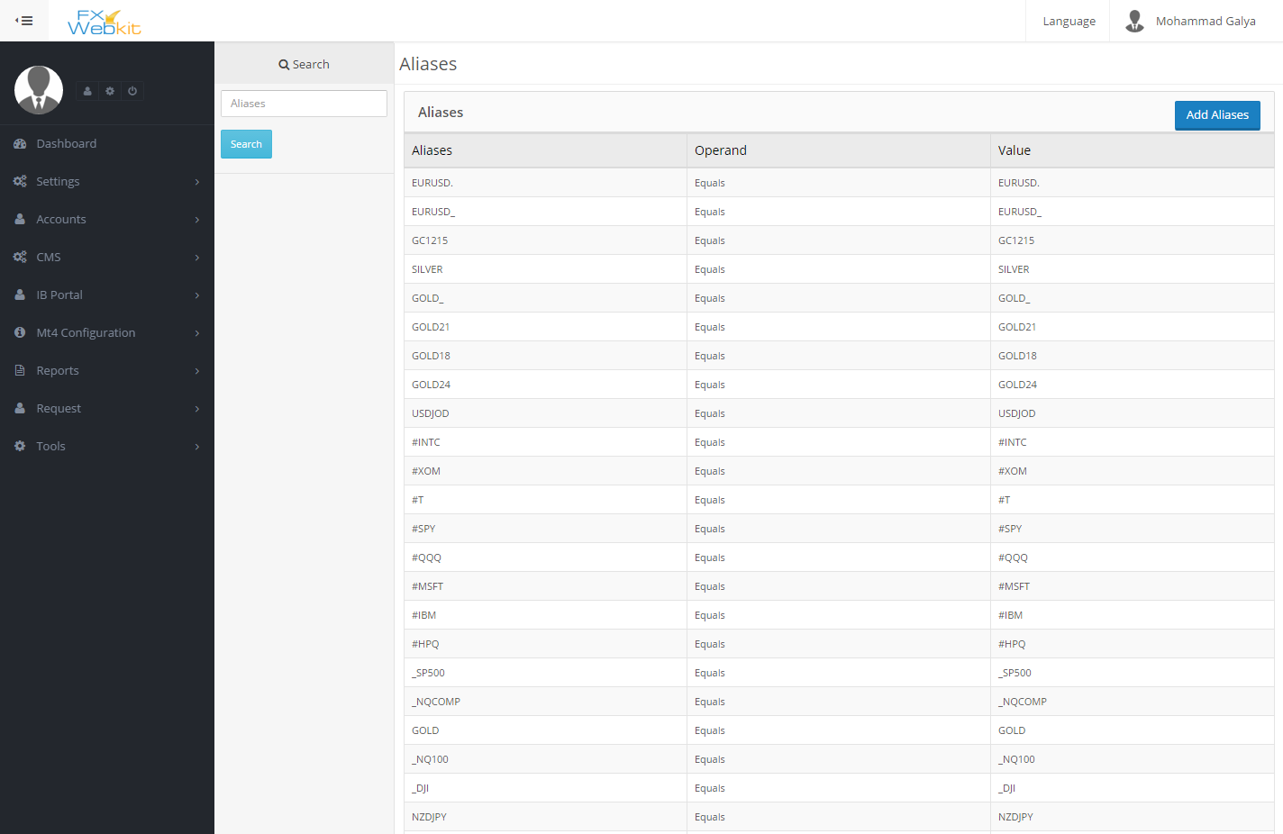

List of aliases with search panel and add new aliases.

Agents List:

Agents users are the users who are agree the agent agreement in IBPORTAL client area .

There is some users register in the FXWEBKIT software through him because for each agent plan there is link if any user register through this link this new user will be on agent users list and so with each trade for user the system calculate agent commission according to plan that the user register with its link.

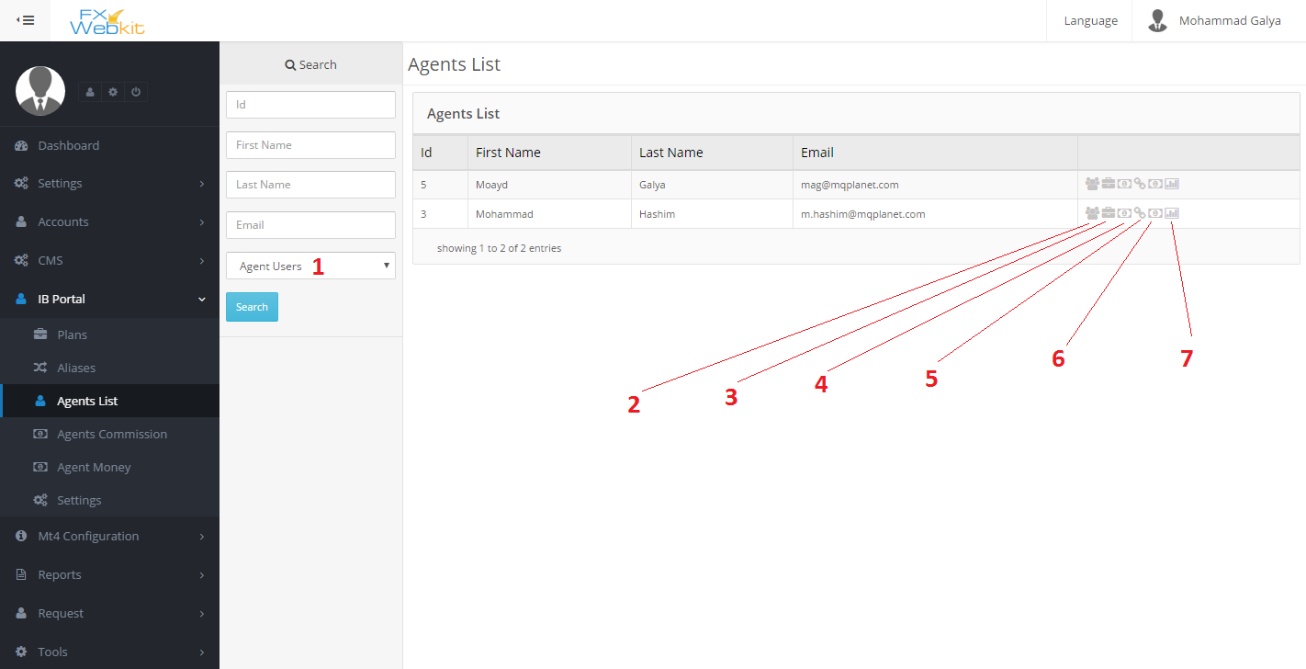

1. Filter users : if you want to see all users and make one of them agent without his agree on agreement just select non agent users and search then click on plus sign for the user.
2. Agent users: all users for this agent who register through him will be listed here .
3. Agent Plans: all the plans for this agent will be listed.
4. Agent Commission : agent commission for his users trades.
5. MT user To give money for agent: in this page you can determine MT4 user to transfer the agent money to.
6. Agent money: the list of money for the agent.
7. Agent Summary : some statistics and info for agent.

**Agents’ Commissions:**

List of all agents’ commissions with filtrations:

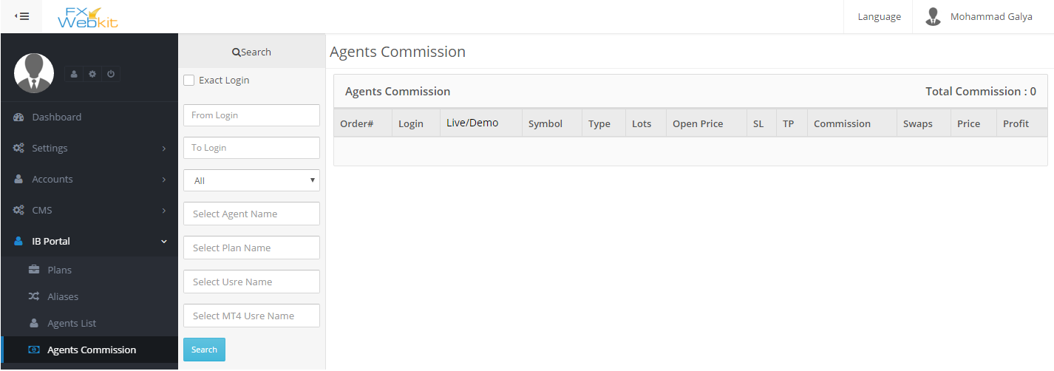

Agents’ Money:

List of all agents’ money with filtrations:

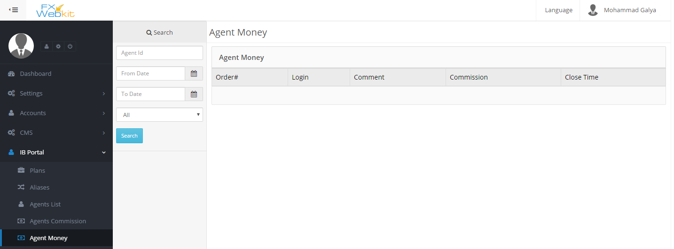

IBPORTAL settings:

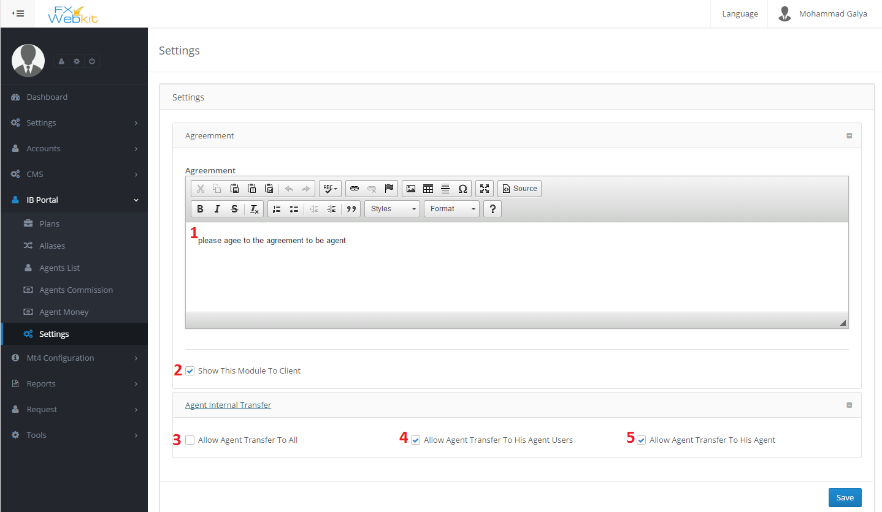

1. Agent agreement : this agreement will be display for agent when he agree on it he will be agent.
2. Show This Module to client: to hide this module from client area or show it.
3. Allow Agent transfer to all: This allow agent transfer money to all MT4 users.
4. Allow agent transfer To his agent users: this allow agent transfer money to MT users of agent users.
5. Allow agent transfer to his agent : just to his MT users.

MT4 Configurations :  
The symbols , groups and securities lists come from MT server this module to get this lists from server and some API configurations.

Symbols List:

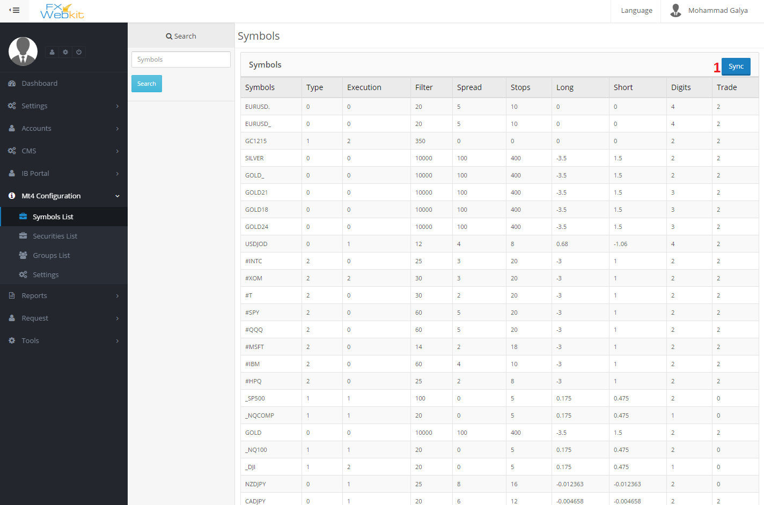

1. Synchronize : synchronize symbols with symbols on MT server.

Securities List:

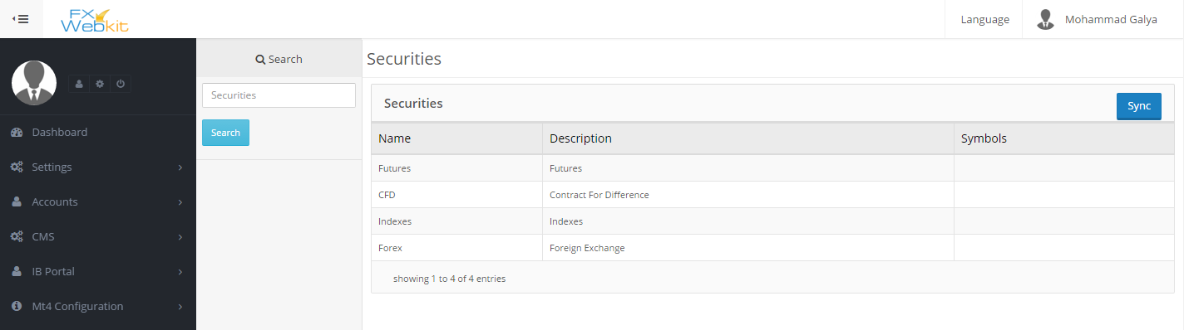

Groups List:

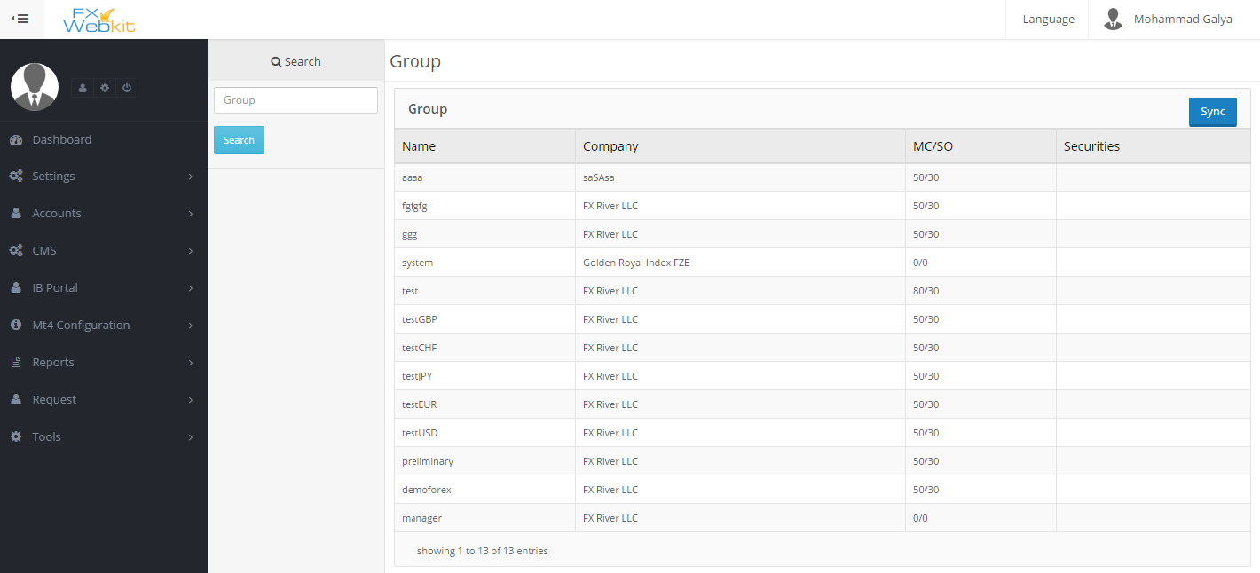

Settings:

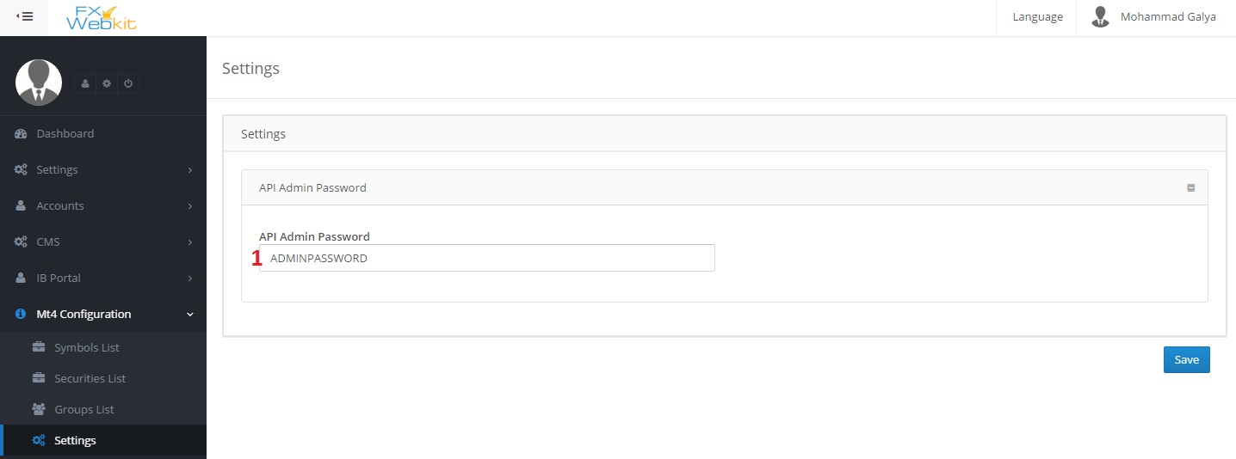

1. API Admin Password : This password to be sent with request for MT server , ask server API for it.

Reports :

Reports about all trades and its users

Closed Orders:

All trades closed orders for all users with filtrations:

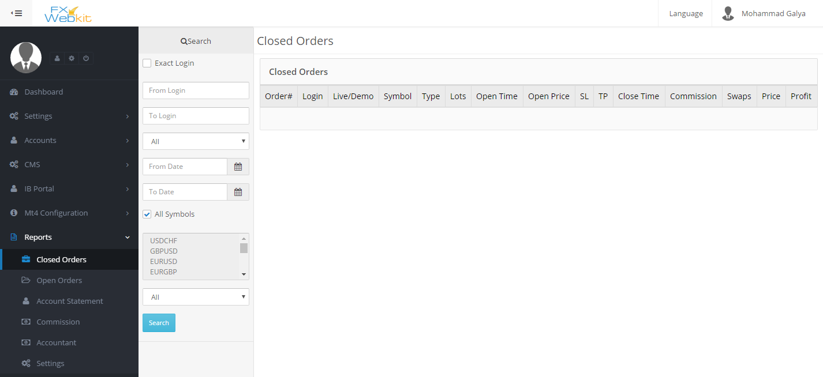

Open Trades:

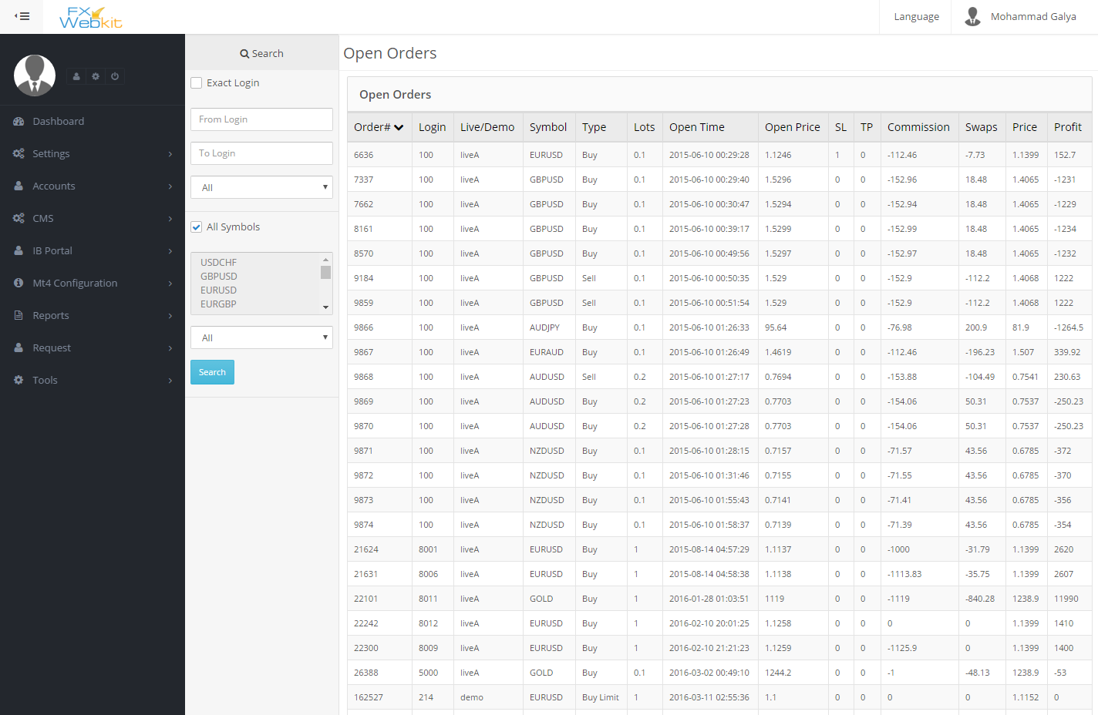

Account Statement :

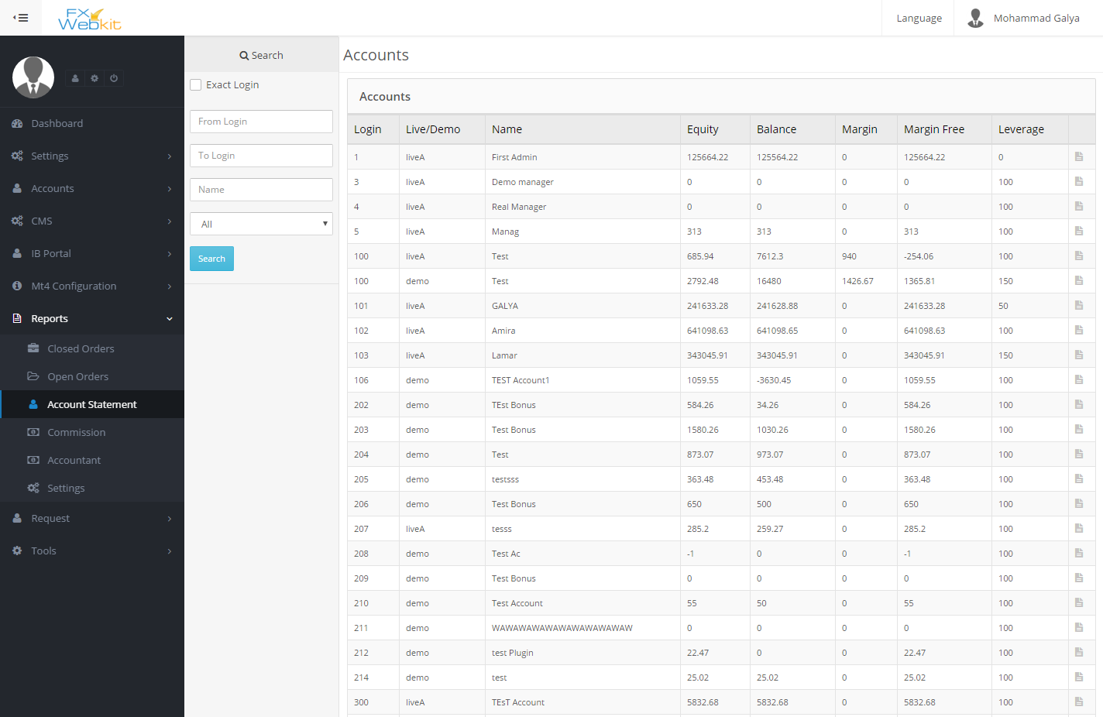

Commission :

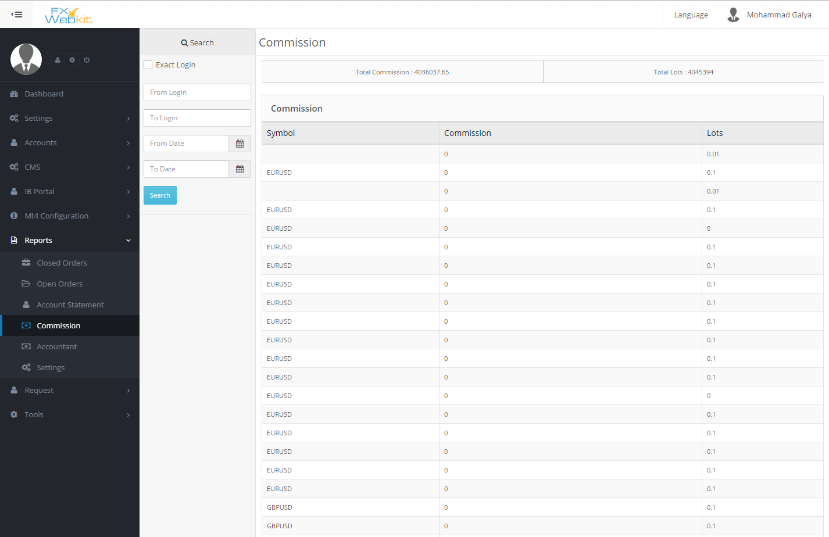

Accountant :

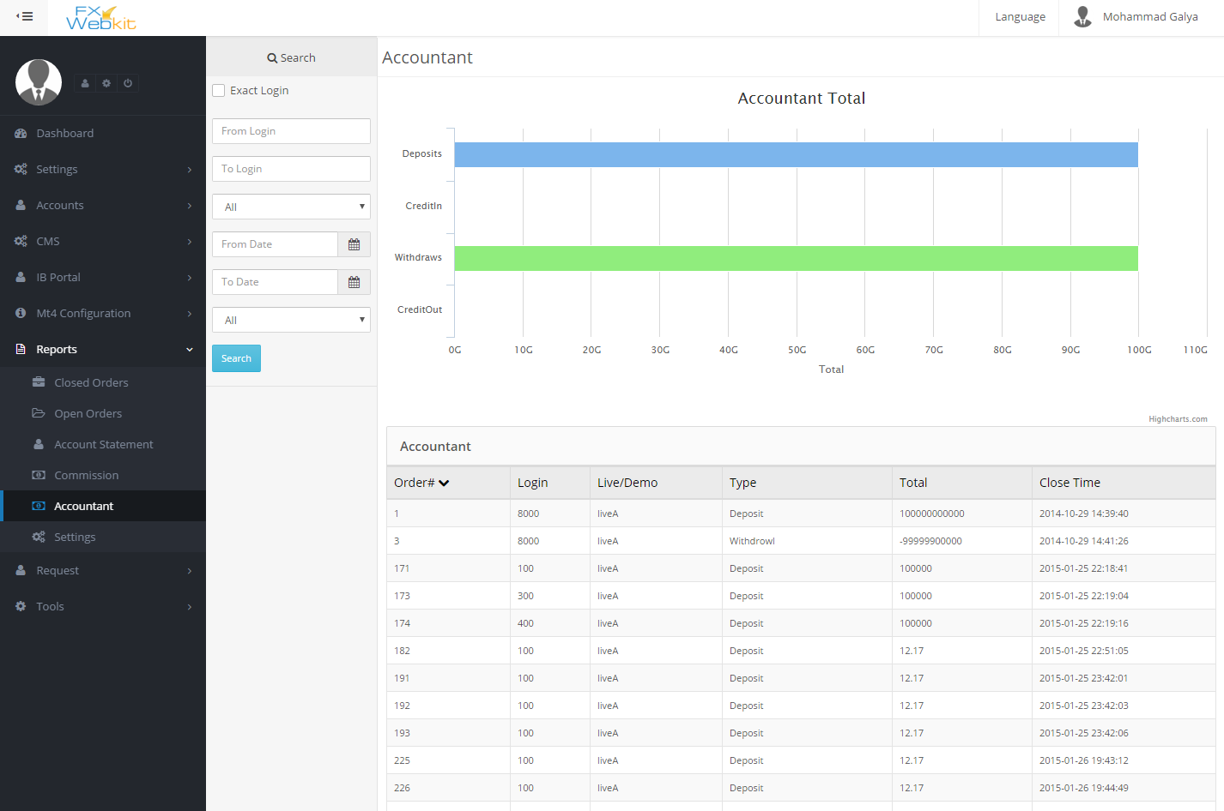

Settings:

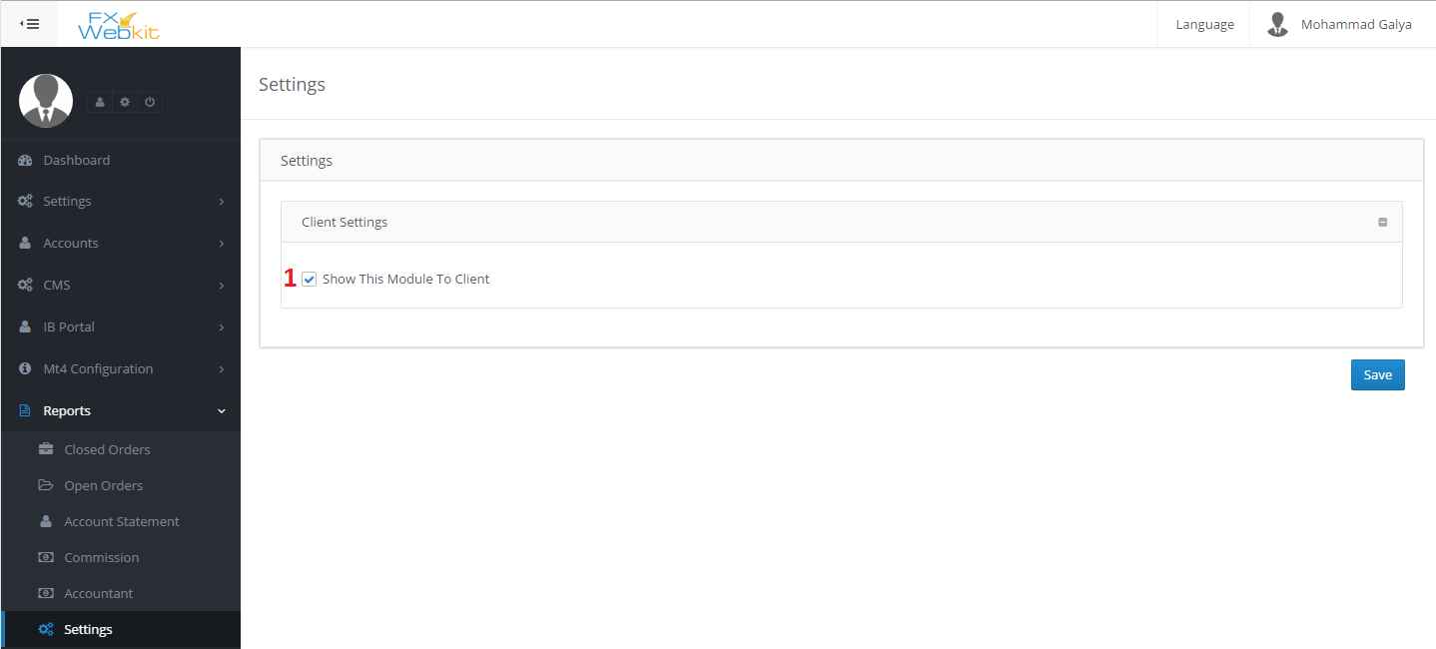

1. Show this module to client : show and hide this module from client area .

Requests:

This module to filter the client requests to the server and control them.

All users requests for MT4 server will be inserted in this module if the admin not check **DIRECT ORDER TO MT4 SERVER**

See accounts module settings

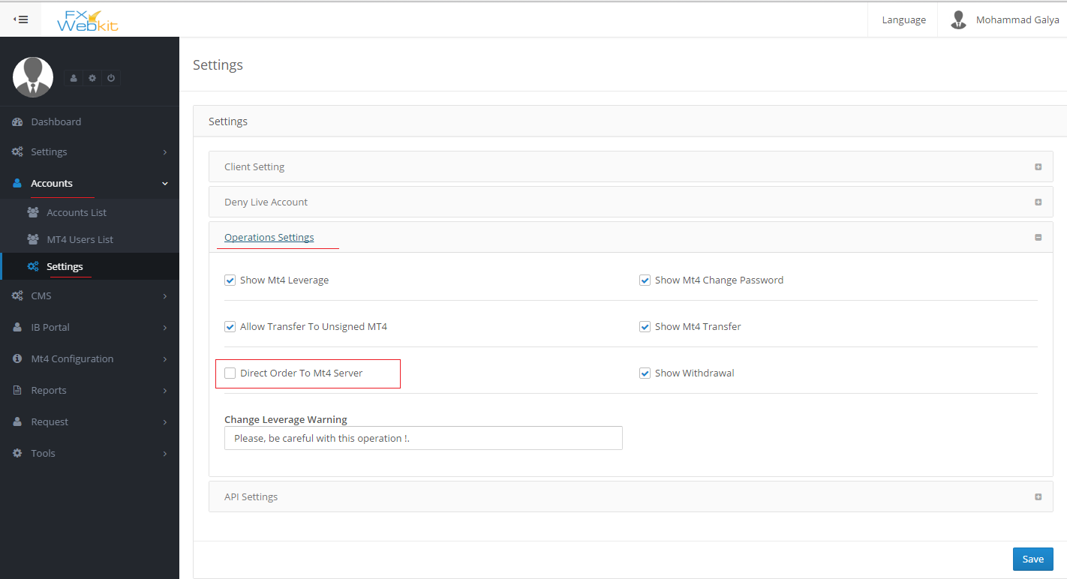

Features:

1. Full control to the MT server requests.
2. Complete the requests manual or forward it to the server.

Sections:

Internal Transfer :

All Internal transfer requests (if admin does not check direct request to the server) will listed here with request status .

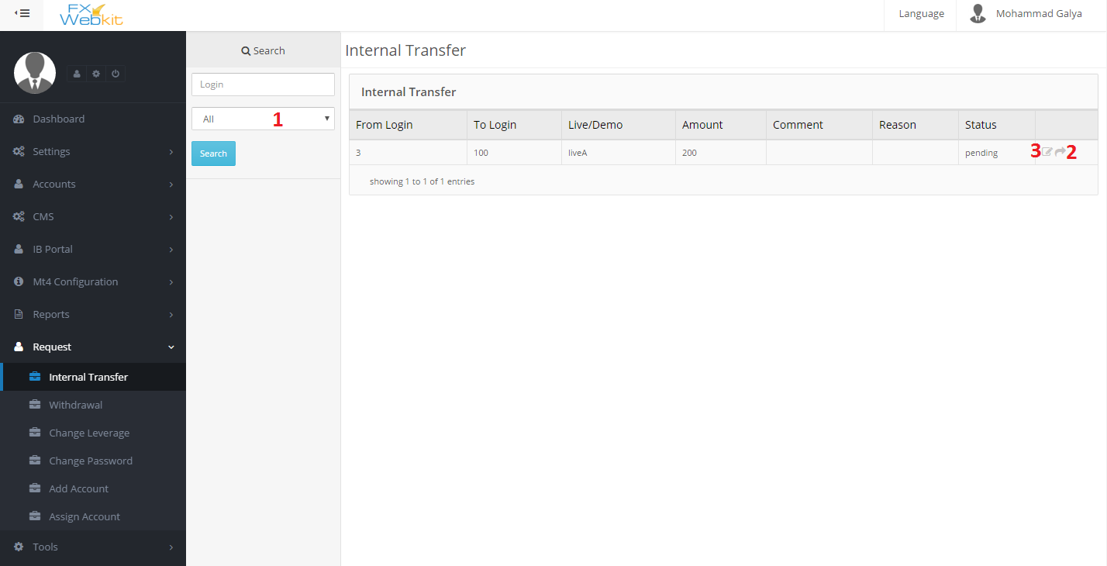

1. Filter requests : to list the requests according to status (all - fail – pending – complete) , just select the status and click search.
2. Forward request: to forward the request to the server if the status is pending.
3. Edit request : you can edit the request status, comment and reason .

Same thing for

Withdrawal requests, Change leverage requests, Change Password requests, and Add Account request.

But the Assign Account request when you change the status manual to complete the MT4 user will be assigned to the client(FXWEBKIT user).

Tools Module:

This module contain some tools to help manage the trades .

Features:

1. Manage contracts and expiry contract.
2. Check the holidays and trades hours and market watch.

Contents:

Future contracts:

When the contract expired there will be an email to the admin to users to till them there is expiry contracts

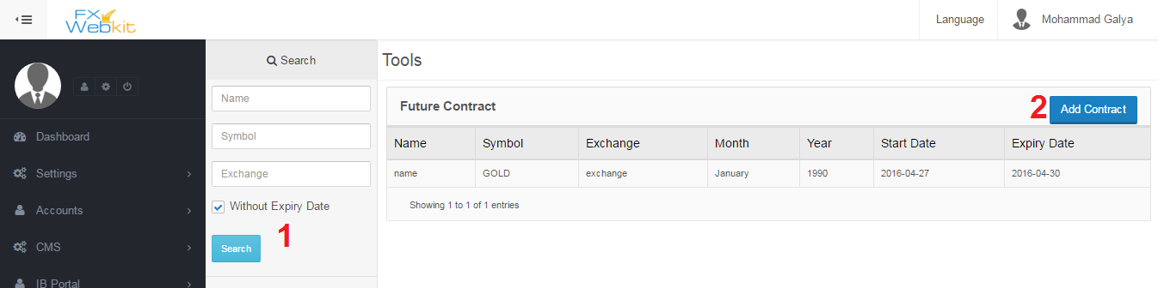

1. Filtration panel : filter the contracts and click search button.
2. Add New contract : to insert new contract :

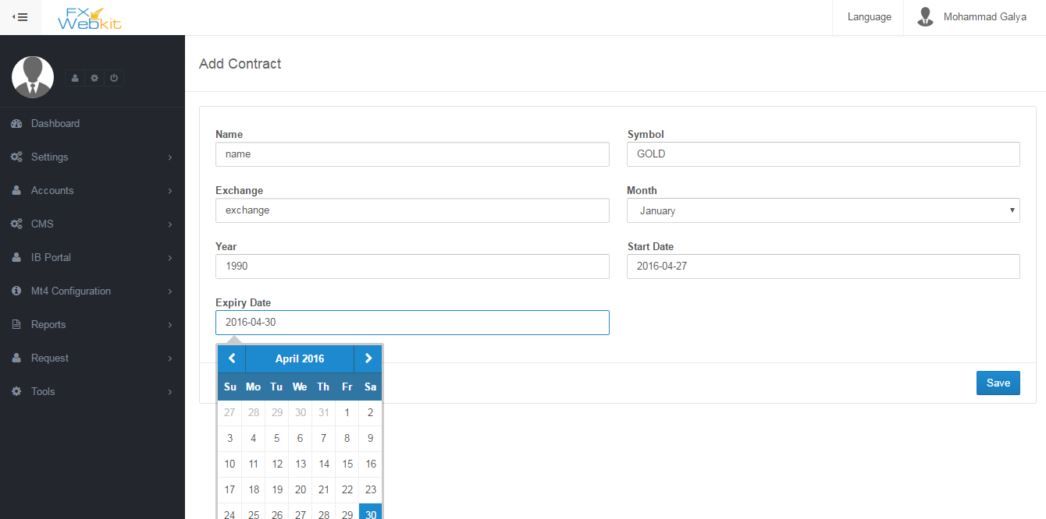

Market Watch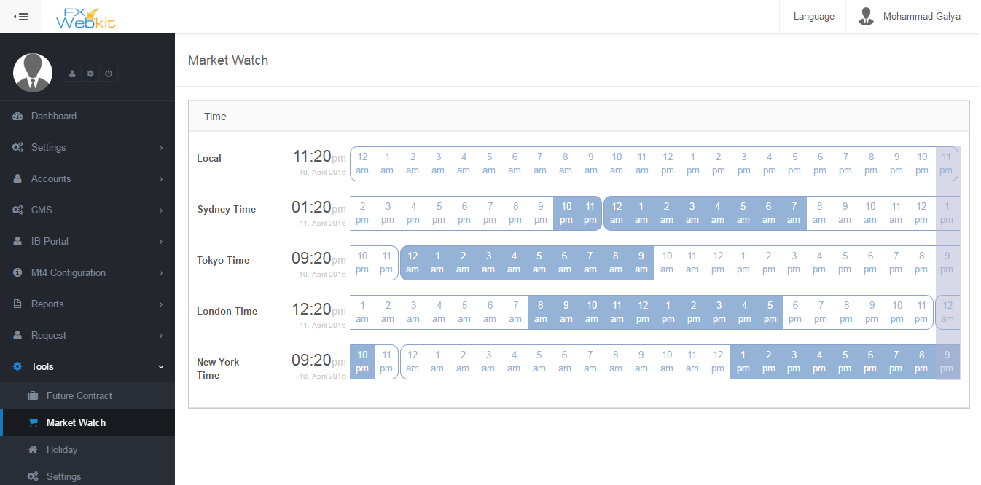

The blue color on time line represents open market.

Holidays :

In holidays we have to determine the open trade hours for each symbol:

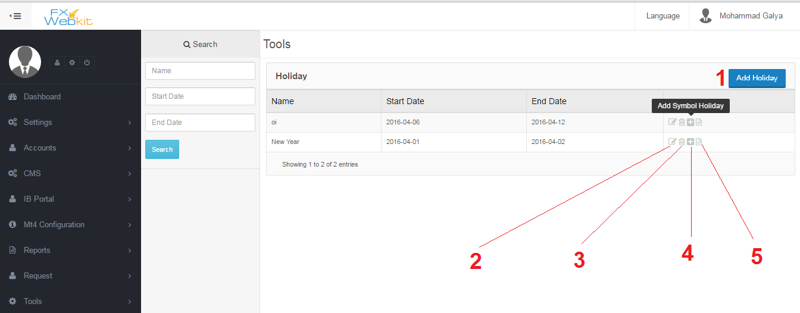

1- add Holiday : this link allow you to insert basic holiday info ( holiday name – from date – to date) and to determine the trade hours for each symbol through this holiday (see number 4) .

2- Edit holiday basic info : just to edit basic holiday info ( holiday name – from date – to date).

1. Delete holiday : remove the holiday and all info.
2. Add symbol holiday : determine the trades hours for each symbol through this holiday select the symbols group in some date and from hour to hour and click add then add another group of symbols with different time trades hour .
3. Holiday details : to see holiday details

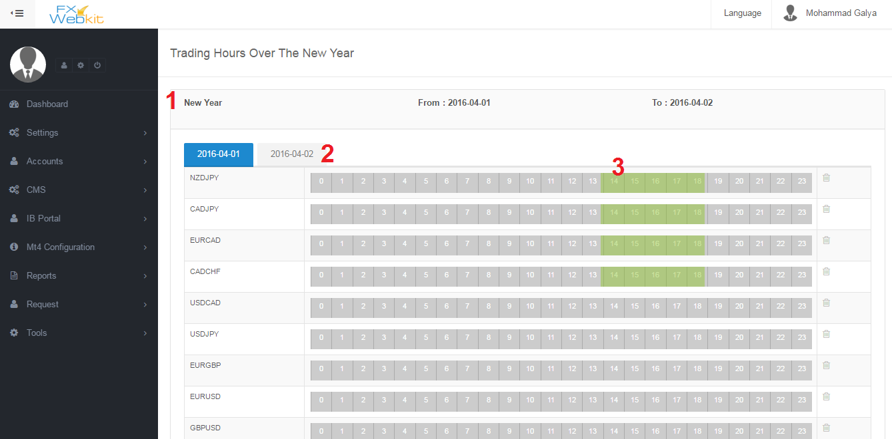

1 – holiday details : basic holiday details.

2 – dates of symbols trade hours :when you add symbols for the holiday you select the date for trade hours for symbols and for each new date there will be new tab.

3 – Trade hours : the green color represent the open market for this symbol which listed on the left.

Settings :

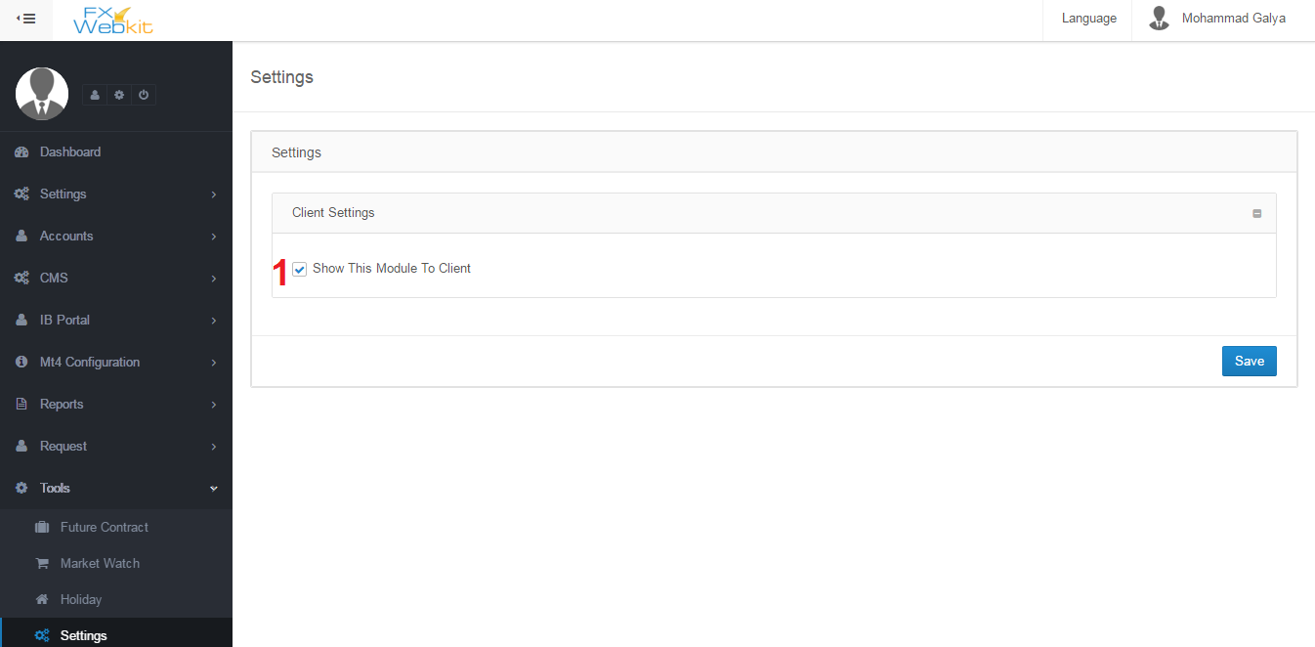

1 – hide and display module in the client area .